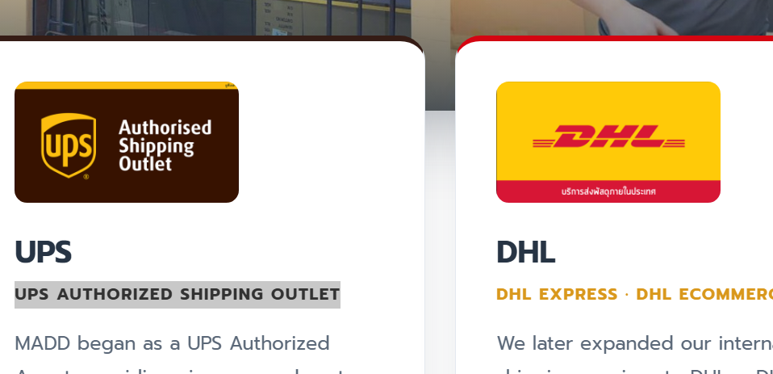
[ช่องที่ 1: UPS]
UPS Express UPS Authorized Shipping Outlet As an official authorized outlet in Thailand, we provide flexible international shipping options with a choice of premium Express or economical tiers to match your specific timeline and budget.
[ช่องที่ 2: DHL]
DHL Express Fast, reliable, time-critical courier service connecting you to over 200 countries worldwide. Designed for urgent business documents and high-value packages requiring expedited handling and security.
[ช่องที่ 3: Sagawa]
Sagawa Express Dedicated cross-border shipping from Thailand to Japan utilizing professional logistics networks. Enjoy dependable handling, cross-border tracking access, and trusted final-mile delivery across Japan.
..................................................................

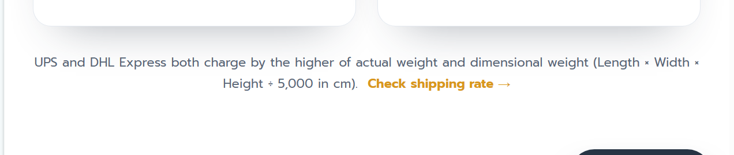

ใช้ข้อความข้างล่างแทนตรงใต้ข้อความ More Than Just Shipping

More Than Just Parcel Delivery
From personal shipments to commercial goods, we bring together trusted international shipping partners and flexible services to support your shipping needs.

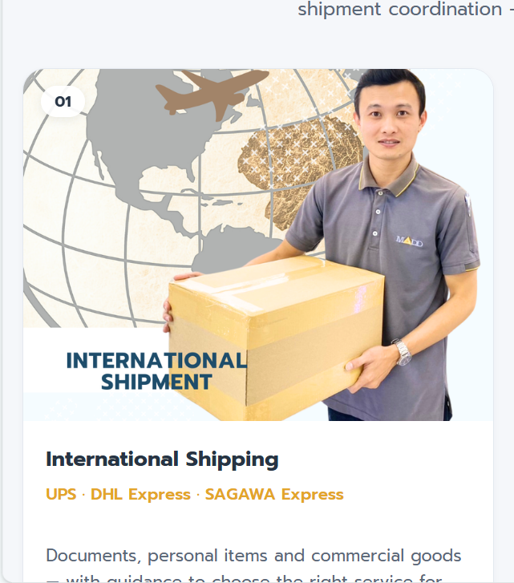

OUR SERVICES 4 ช่อง

ช่องที่ 1 International Shipping

UPS – Flexible International Shipping
As an official UPS Authorized Shipping Outlet in Thailand, MADD offers direct access to UPS's comprehensive global network. Customers can select from premium Express options or economical shipping tiers to align with their target timelines and budget requirements.
- Flexible Service Tiers: Choose between express or economy solutions based on your specific budget and urgency.
- Global Network Reach: Reliable transport of documents, parcels, and commercial goods to international destinations, including selected remote areas.
- End-to-End Tracking: Monitor your shipment’s progress online from initial dispatch until final delivery.
- Versatile Shipping Solutions: Tailored to support individuals, e-commerce stores, SMEs, and cross-border exporters.

DHL – Fast & Reliable International Shipping
For time-critical shipments, MADD provides access to DHL Express international shipping services from Thailand. DHL Express is a practical choice for urgent business documentation, high-value packages, and commercial shipments requiring expedited handling.
- International Express Courier: Prompt door-to-door delivery designed to maximize speed and security.
- Extensive Global Network: Connectivity spanning more than 200 countries and territories worldwide.
- Shipment Tracking Status: Check your parcel's estimated delivery and status anytime through the available tracking service.
- E-Commerce & Business Support: Streamlined options for online merchants and business operators handling time-sensitive international demands.

Sagawa Express – Dedicated Shipping from Thailand to Japan
When looking to ship from Thailand to Japan, MADD provides a dedicated transport route utilizing the logistics capabilities of Sagawa Express. As a widely recognized domestic parcel delivery brand in Japan, Sagawa ensures dependable handling for final delivery.
- Japan-Wide Coverage: Shipping arrangements covering major cities and regional prefectures across Japan, subject to local service availability.
- Cross-Border Tracking Access: Follow your shipment's route from our facility through to the local domestic courier network in Japan.
- Personal & Commercial Freight: Equipped to process personal belongings, gifts, and commercial export goods destined for Japan.
- Local Final-Mile Logistics: Benefit from Sagawa Express’s established Japanese domestic fleet for professional final-mile distribution.

ใต้รูป

ข้อความใต้รูปนี้ UPS and DHL Express both charge by the higher of actual weight and dimensional weight (Length × Width × Height ÷ 5,000 in cm). เปลี่ยนเป็นใช้ความข้างล่างนี้แทน

Standard Terms & Disclaimers
- Transit Times: All delivery timeframes provided are estimates and subject to customs clearance procedures, airline schedules, and local destination conditions.
- Tracking Updates: Shipment tracking availability and update frequencies vary according to the respective global carrier’s network and regional infrastructure.
- Service Availability: Delivery to specific destinations or remote areas is subject to the service terms, conditions, and coverage zones of our international shipping partners.

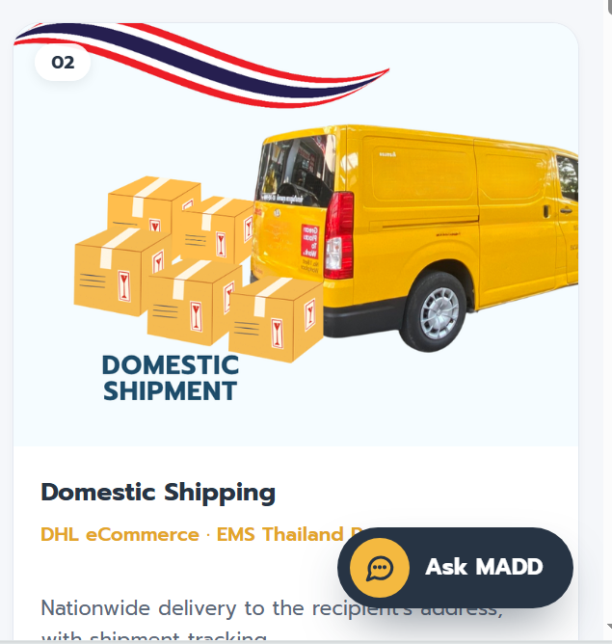

ช่องที่ 2

Domestic Shipping within Thailand
We provide reliable domestic shipping for documents, parcels, and e-commerce shipments across Thailand, mainly via DHL eCommerce. EMS services by Thailand Post are also available at our Bangkapi branch for added convenience

Service Highlights:
• Fast nationwide delivery across all regions in Thailand
• On-time delivery with proactive updates
• Real-time tracking for complete visibility
• Convenient for individuals, SMEs, and online businesses

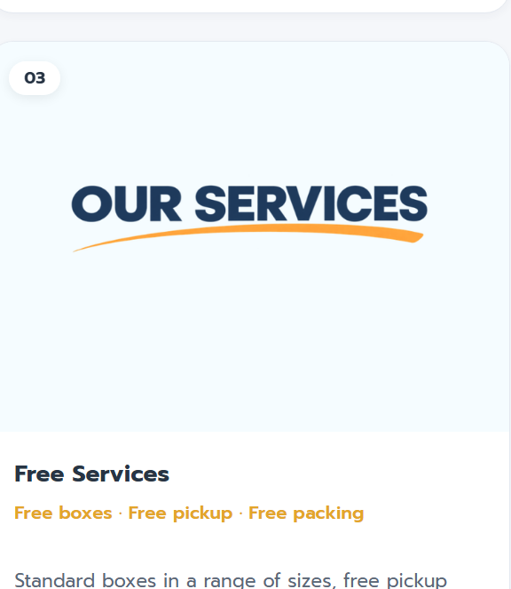

ช่องที่ 3

Free Services for International Shipments

We offer a range of free services designed to support cost-effective and efficient international shipping from Thailand.

Free Standard Shipping Boxes

We provide multiple standard box sizes designed to suit your items’ size and weight for safe and cost-efficient international shipping.
Service Highlights:
• Strong protection: Durable materials ensure safe handling during transit
• Cost efficiency: Reduce overall shipping costs
• Optimized handling: Designed to meet international carrier requirements

Pick-Up & Packing Services

We make international shipping simple and more convenient.

Service Highlights:
• Free pickup: Available within selected Bangkok area near our 6 branches
• Free professional packing: In accordance with DHL & UPS standards
• Complete documentation preparation: Air Waybill, Invoice, and Packing List
• Free standard packing materials: Shredded paper, OPP tape, and protective fillers

Additional Charges (if requested):
• Special packing materials (e.g., bubble wrap, foam sheets, fumigated wooden boxes)
• Tin boxes for high-value shipments (e.g., silver accessory shipment)
• Additional export documentation (if required)

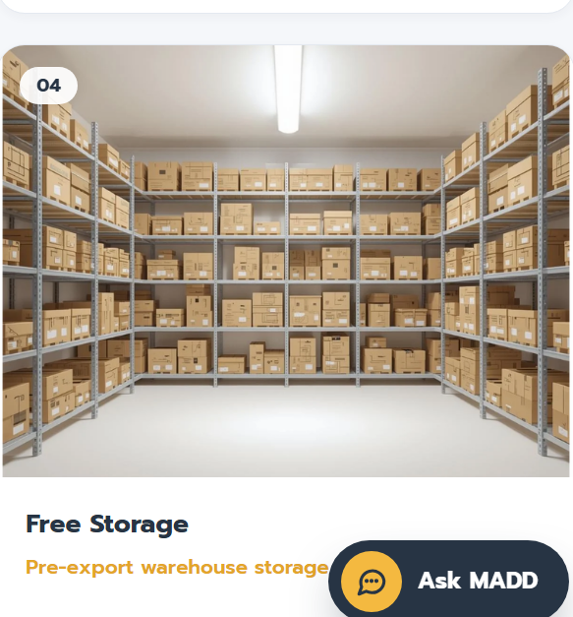

ช่องที่ 4

Free Warehouse Storage & Inventory Management
We offer free pre-export warehouse storage complete with comprehensive inventory oversight, quality control, and systematic management. Every item is carefully inspected, recorded, and handled through a structured process to ensure maximum security, accuracy, and readiness for packing and shipment.
Designed to support international shipping and export logistics, this service helps streamline operations, reduce complexity, and improve overall efficiency—all at no service charge.

Service Highlights
- Simplified Supplier Coordination: Easily manage multiple suppliers and consolidate goods into a single shipment.
- Accuracy You Can Trust: Enjoy peace of mind with thorough inspections, quantity verification, and quality checks to minimize errors.
- Clear Visibility: Gain full transparency with detailed reports and photo documentation, keeping you informed about your inventory status.
- Secure and Organized Storage: Rest assured knowing your goods are professionally handled and securely stored at all times.
- Reduced Risk and Delays: Controlled processes minimize damage and help prevent export delays.

